**GAME DEVELOPMENT (COMP3540 / COMP6540)**

**DEVELOPER DIARY ENTRY**

|  |  |
| --- | --- |
| UID: | Name: Lingxiu Cai |
| Diary: *4* | Week: *11* |

*All word limits are maximums – do not exceed them. Only write what you need.*

**Work Log**

*Log the hours you worked and details of tasks you have completed. List one task per row and add rows as necessary. These are tasks that you personally completed, or your personal contribution to group tasks. Each task should have at least one piece of associated evidence (see Work Evidence). (No word limit, but be concise).*

|  |  |
| --- | --- |
| **Task Description** | **Date/Time worked** |
| Personal Game development work (Figure 1, 2, 3, 4, 5)  - Refinement: made adjustment to the axe and window clues to enhance player understanding and interaction.  - Hint System: Implemented a blinking text hint feature for the clues. If a player doesn't interact with the clue within 10s, a text hint will appear, guiding them in the right direction.  - Evaluation: Add an evaluation session for clues, which aims to improve the effectiveness and clarity of each clue.  - New clue: Introduced the bed clue, where players will identify a piece of clothing caught by the bed, adding another important clue to help players find the real murder. | 10/15 ~10/18  Every night |
| Player Testing during workshop:  Attended the player testing session during the workshop to gather feedback on the game features currently in the game. | 10/19 11:00~13:00 |
| Team meeting:  - Code integration: merged individual development branches to unify process and streamline team efforts.  - Next week's task arrangement: discussed the tasks for next week development according to the feedback we get from the player test. And also discussed the potential removal of the hint function, which will be decided upon through a team vote later. | 10/19 16:30 ~ 19:00 |
|  |  |

**Challenges/Questions**

*Identify and discuss any challenges or questions that you encountered in completing your tasks this week. (200 words maximum)*

|  |
| --- |
| One of the primary challenges faced this week was ensuring that the clues in the game were intuitive and easily understood by players. During the refinement of the axe and window clues, it became evident that players often struggled with puzzle logic, indicating a disconnect between the game's design and player expectations. Balancing the level of challenge without making the clues too obvious was a tightrope walk.  Another significant challenge was the ambient lighting of the escape room. Feedback from the player testing workshop highlighted that the current lighting setup was too dim, obscuring crucial game elements and potentially frustrating players. Adjusting the lighting without compromising the game's ambience and mood required careful adjustment.  The floating room environment feedback further underlined the need to ensure the game's setting was both engaging and believable. Creating a realistic ground without disrupting the current design posed another challenge.  Lastly, integrating individual work during team meetings brought its own set of difficulties. Merging branches, aligning on task priorities, and ensuring that every team member was on the same page was a meticulous process, further complicated by the impending deadline for individual clues. |

**Strategies/Learnings**

*Identify and discuss the strategies you used to solve challenges, answer questions, and what you learned. (200 words maximum)*

|  |
| --- |
| To address the challenge of making puzzles intuitive yet challenging, we initiated a two-pronged approach. First, hint texts were introduced, which would activate after a set duration, offering players a nudge in the right direction. Second, we looked into adding particle effects to interactable objects, giving players a visual cue and a more immersive experience.  Merging individual branches without conflicts was vital. We opted for frequent communication, updating each other on individual progress, and ensuring all team members had clarity on tasks. This pre-emptive communication strategy reduced potential conflicts during branch merges.  The week underscored the importance of iterative testing and feedback incorporation. It also highlighted the value of communication in team projects, especially when working with multiple branches and interdependent tasks. Being adaptable and open to changes based on feedback was essential for the project's ongoing success. |

**Work Evidence**

*Demonstrate the work you have completed (sketches, links, code).* *Any evidence added here should be numbered and referenced in the Work Log table above. Each task should have at least one piece of evidence.*

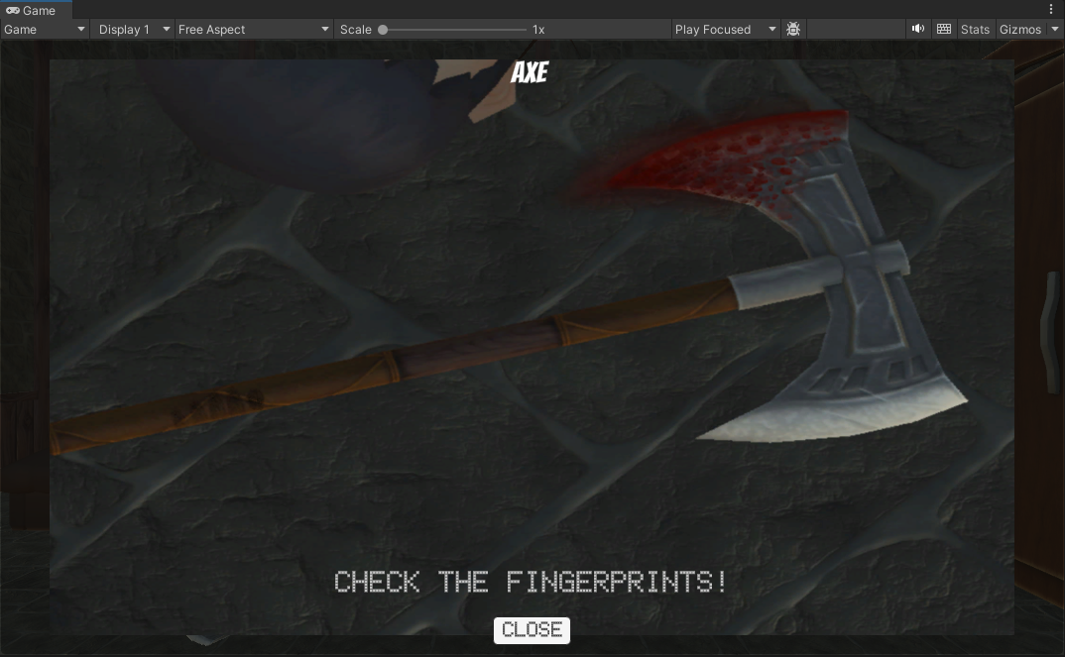

**Figure 1, 2, 3: Refine Axe and Window clue, add hint and evaluate session for the clue.**

**Figure 4, 5: Finish the bed clue.**

**Figure 6: Player test feedback.**

**Figure 7: Next week tasks arrangement.**